**Data Structure**

A data structure is a particular way of organizing data in a computer so that it can be used effectively. The idea is to reduce the space and time complexities of different tasks. Below is an overview of some popular linear data structures.

[1. Array](https://www.geeksforgeeks.org/overview-of-data-structures-set-1-linear-data-structures/#code1)  
[2. Linked List](https://www.geeksforgeeks.org/overview-of-data-structures-set-1-linear-data-structures/#code2)  
[3. Stack](https://www.geeksforgeeks.org/overview-of-data-structures-set-1-linear-data-structures/#code3)  
[4. Queue](https://www.geeksforgeeks.org/overview-of-data-structures-set-1-linear-data-structures/#code4)

**Array**

Array is a container which can hold a fix number of items and these items should be of the same type. Most of the data structures make use of arrays to implement their algorithms. Following are the important terms to understand the concept of Array.

* **Element** − Each item stored in an array is called an element.
* **Index** − Each location of an element in an array has a numerical index, which is used to identify the element.

**Basic Operations**

Following are the basic operations supported by an array.

* **Traverse** − print all the array elements one by one.
* **Insertion** − Adds an element at the given index.
* **Deletion** − Deletes an element at the given index.
* **Search** − Searches an element using the given index or by the value.
* **Update** − Updates an element at the given index.

## Traverse Operation

This operation is to traverse through the elements of an array.

## Insertion Operation

Insert operation is to insert one or more data elements into an array. Based on the requirement, a new element can be added at the beginning, end, or any given index of array.

Here, we see a practical implementation of insertion operation, where we add data at the end of the array −

1. If(M<N) then BACK=M+1 else STOP   
 2. While (BACK>i) repeat steps 3 to 4   
 3. REG[BACK]= REG[BACK-1]   
 4. BACK=BACK-1;   
 5. Reg[BACK]='X'   
 6. M=M+1   
 7. End.

## Deletion Operation

Deletion refers to removing an existing element from the array and re-organizing all elements of an array.

### Algorithm

Consider **LA** is a linear array with **N** elements and **K** is a positive integer such that **K<=N**. Following is the algorithm to delete an element available at the Kth position of LA.

1. Start

2. Set J = K

3. Repeat steps 4 and 5 while J < N

4. Set LA[J] = LA[J + 1]

5. Set J = J+1

6. Set N = N-1

7. Stop

### Example

## Search Operation

You can perform a search for an array element based on its value or its index.

### Algorithm

Consider **LA** is a linear array with **N** elements and **K** is a positive integer such that **K<=N**. Following is the algorithm to find an element with a value of ITEM using sequential search.

1. Start

2. Set J = 0

3. Repeat steps 4 and 5 while J < N

4. IF LA[J] is equal ITEM THEN GOTO STEP 6

5. Set J = J +1

6. PRINT J, ITEM

7. Stop

## Update Operation

Update operation refers to updating an existing element from the array at a given index.

### Algorithm

Consider **LA** is a linear array with **N** elements and **K** is a positive integer such that **K<=N**. Following is the algorithm to update an element available at the Kth position of LA.

1. Start

2. Set LA[K-1] = ITEM

3. Stop

**Linked List**

A linked list is a sequence of data structures, which are connected together via links.

Linked List is a sequence of links which contains items. Each link contains a connection to another link. Linked list is the second most-used data structure after array. Following are the important terms to understand the concept of Linked List.

* **Link** − Each link of a linked list can store a data called an element.
* **Next** − Each link of a linked list contains a link to the next link called Next.
* **LinkedList** − A Linked List contains the connection link to the first link called First.

## Types of Linked List

Following are the various types of linked list.

* **Simple Linked List** − Item navigation is forward only.
* **Doubly Linked List** − Items can be navigated forward and backward.
* **Circular Linked List** − Last item contains link of the first element as next and the first element has a link to the last element as previous.

## Basic Operations

Following are the basic operations supported by a list.

* **Insertion** − Adds an element at the beginning of the list.
* **Deletion** − Deletes an element at the beginning of the list.
* **Display** − Displays the complete list.
* **Search** − Searches an element using the given key.
* **Delete** − Deletes an element using the given key.

**Insertion Operation**

Adding a new node in linked list is a more than one step activity. We shall learn this with diagrams here. First, create a node using the same structure and find the location where it has to be inserted.

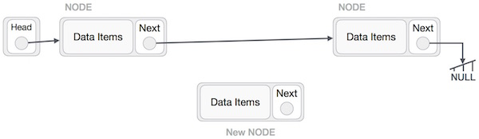

Imagine that we are inserting a node **B** (NewNode), between **A** (LeftNode) and **C** (RightNode). Then point B.next to C −

NewNode.next −> RightNode;

It should look like this −

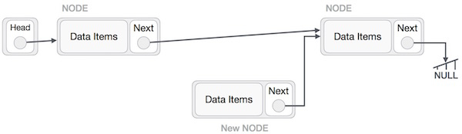

Now, the next node at the left should point to the new node.

LeftNode.next −> NewNode;

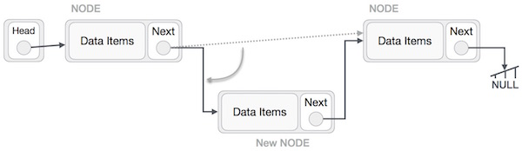

This will put the new node in the middle of the two. The new list should look like this −

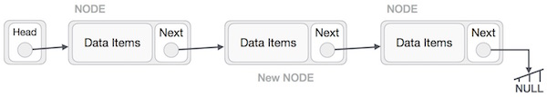

Similar steps should be taken if the node is being inserted at the beginning of the list. While inserting it at the end, the second last node of the list should point to the new node and the new node will point to NULL.

**Deletion Operation**

Deletion is also a more than one step process. We shall learn with pictorial representation. First, locate the target node to be removed, by using searching algorithms.

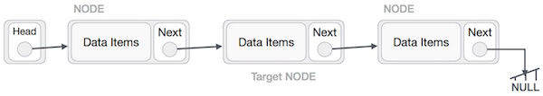

The left (previous) node of the target node now should point to the next node of the target node −

LeftNode.next −> TargetNode.next;

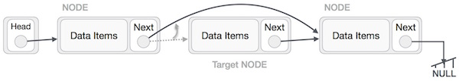

This will remove the link that was pointing to the target node. Now, using the following code, we will remove what the target node is pointing at.

TargetNode.next −> NULL;

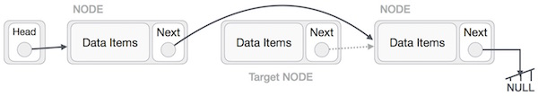

We need to use the deleted node. We can keep that in memory otherwise we can simply deallocate memory and wipe off the target node completely.

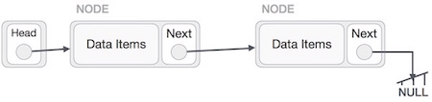

**Reverse Operation**

This operation is a thorough one. We need to make the last node to be pointed by the head node and reverse the whole linked list.

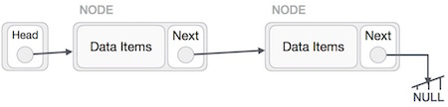

First, we traverse to the end of the list. It should be pointing to NULL. Now, we shall make it point to its previous node −

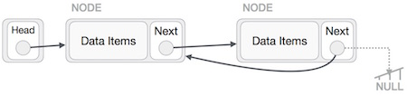

We have to make sure that the last node is not the last node. So we'll have some temp node, which looks like the head node pointing to the last node. Now, we shall make all left side nodes point to their previous nodes one by one.

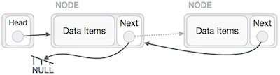

Except the node (first node) pointed by the head node, all nodes should point to their predecessor, making them their new successor. The first node will point to NULL.

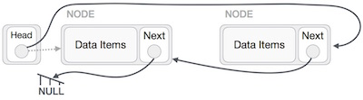

We'll make the head node point to the new first node by using the temp node.

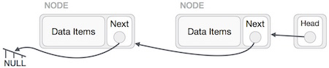

The linked list is now reversed.

**Doubly Linked List**

Doubly Linked List is a variation of Linked list in which navigation is possible in both ways, either forward and backward easily as compared to Single Linked List. Following are the important terms to understand the concept of doubly linked list.

* **Link** − Each link of a linked list can store a data called an element.
* **Next** − Each link of a linked list contains a link to the next link called Next.
* **Prev** − Each link of a linked list contains a link to the previous link called Prev.
* **LinkedList** − A Linked List contains the connection link to the first link called First and to the last link called Last.

**Doubly Linked List Representation**

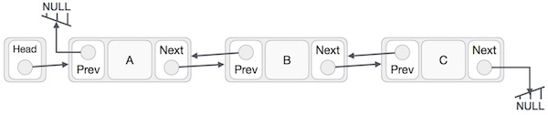

As per the above illustration, following are the important points to be considered.

* Doubly Linked List contains a link element called first and last.
* Each link carries a data field(s) and two link fields called next and prev.
* Each link is linked with its next link using its next link.
* Each link is linked with its previous link using its previous link.
* The last link carries a link as null to mark the end of the list.

**Stack**

A stack is an Abstract Data Type (ADT), commonly used in most programming languages. It is named stack as it behaves like a real-world stack, for example – a deck of cards or a pile of plates, etc.

A real-world stack allows operations at one end only. For example, we can place or remove a card or plate from the top of the stack only. Likewise, Stack ADT allows all data operations at one end only. At any given time, we can only access the top element of a stack.

This feature makes it LIFO data structure. LIFO stands for Last-in-first-out. Here, the element which is placed (inserted or added) last, is accessed first. In stack terminology, insertion operation is called **PUSH** operation and removal operation is called **POP** operation.

## Stack Representation

The following diagram depicts a stack and its operations −

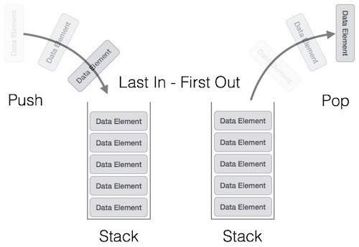

A stack can be implemented by means of Array, Structure, Pointer, and Linked List. Stack can either be a fixed size one or it may have a sense of dynamic resizing. Here, we are going to implement stack using arrays, which makes it a fixed size stack implementation.

## Basic Operations

Stack operations may involve initializing the stack, using it and then de-initializing it. Apart from these basic stuffs, a stack is used for the following two primary operations −

* **push()** − Pushing (storing) an element on the stack.
* **pop()** − Removing (accessing) an element from the stack.

When data is PUSHed onto stack.

To use a stack efficiently, we need to check the status of stack as well. For the same purpose, the following functionality is added to stacks −

* **peek()** − get the top data element of the stack, without removing it.
* **isFull()** − check if stack is full.
* **isEmpty()** − check if stack is empty.

At all times, we maintain a pointer to the last PUSHed data on the stack. As this pointer always represents the top of the stack, hence named **top**. The **top** pointer provides top value of the stack without actually removing it.

First we should learn about procedures to support stack functions −

### peek()

Algorithm of peek() function −

begin procedure peek

return stack[top]

end procedure

### isfull()

Algorithm of isfull() function −

begin procedure isfull

if top equals to MAXSIZE

return true

else

return false

endif

end procedure

### isempty()

Algorithm of isempty() function −

begin procedure isempty

if top less than 1

return true

else

return false

endif

end procedure

Implementation of isempty() function in C programming language is slightly different. We initialize top at -1, as the index in array starts from 0. So we check if the top is below zero or -1 to determine if the stack is empty. Here's the code −

## Push Operation

The process of putting a new data element onto stack is known as a Push Operation. Push operation involves a series of steps −

* **Step 1** − Checks if the stack is full.
* **Step 2** − If the stack is full, produces an error and exit.
* **Step 3** − If the stack is not full, increments **top** to point next empty space.
* **Step 4** − Adds data element to the stack location, where top is pointing.
* **Step 5** − Returns success.

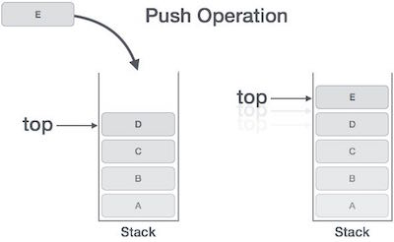

If the linked list is used to implement the stack, then in step 3, we need to allocate space dynamically.

### Algorithm for PUSH Operation

A simple algorithm for Push operation can be derived as follows −

begin procedure push: stack, data

if stack is full

return null

endif

top ← top + 1

stack[top] ← data

end procedure

## Pop Operation

Accessing the content while removing it from the stack, is known as a Pop Operation. In an array implementation of pop() operation, the data element is not actually removed, instead **top** is decremented to a lower position in the stack to point to the next value. But in linked-list implementation, pop() actually removes data element and deallocates memory space.

A Pop operation may involve the following steps −

* **Step 1** − Checks if the stack is empty.
* **Step 2** − If the stack is empty, produces an error and exit.
* **Step 3** − If the stack is not empty, accesses the data element at which **top** is pointing.
* **Step 4** − Decreases the value of top by 1.
* **Step 5** − Returns success.

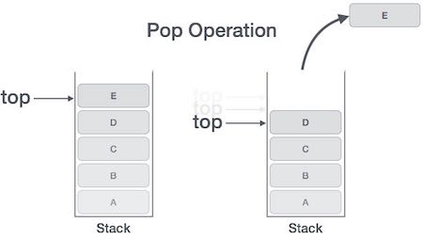

### Algorithm for Pop Operation

A simple algorithm for Pop operation can be derived as follows −

begin procedure pop: stack

if stack is empty

return null

endif

data ← stack[top]

top ← top - 1

return data

end procedure

**Queue**

Queue is an abstract data structure, somewhat similar to Stacks. Unlike stacks, a queue is open at both its ends. One end is always used to insert data (enqueue) and the other is used to remove data (dequeue). Queue follows First-In-First-Out methodology, i.e., the data item stored first will be accessed first.

A real-world example of queue can be a single-lane one-way road, where the vehicle enters first, exits first. More real-world examples can be seen as queues at the ticket windows and bus-stops.

## Queue Representation

As we now understand that in queue, we access both ends for different reasons. The following diagram given below tries to explain queue representation as data structure −

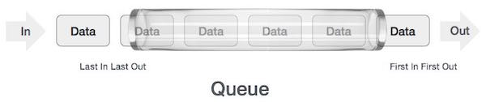

As in stacks, a queue can also be implemented using Arrays, Linked-lists, Pointers and Structures. For the sake of simplicity, we shall implement queues using one-dimensional array.

## Basic Operations

Queue operations may involve initializing or defining the queue, utilizing it, and then completely erasing it from the memory. Here we shall try to understand the basic operations associated with queues −

* **enqueue()** − add (store) an item to the queue.
* **dequeue()** − remove (access) an item from the queue.

Few more functions are required to make the above-mentioned queue operation efficient. These are −

* **peek()** − Gets the element at the front of the queue without removing it.
* **isfull()** − Checks if the queue is full.
* **isempty()** − Checks if the queue is empty.

In queue, we always dequeue (or access) data, pointed by **front** pointer and while enqueing (or storing) data in the queue we take help of **rear** pointer.

Let's first learn about supportive functions of a queue −

### peek()

This function helps to see the data at the **front** of the queue. The algorithm of peek() function is as follows −

**Algorithm**

begin procedure peek

return queue[front]

end procedure

### isfull()

As we are using single dimension array to implement queue, we just check for the rear pointer to reach at MAXSIZE to determine that the queue is full. In case we maintain the queue in a circular linked-list, the algorithm will differ. Algorithm of isfull() function −

**Algorithm**

begin procedure isfull

if rear equals to MAXSIZE

return true

else

return false

endif

end procedure

### isempty()

Algorithm of isempty() function −

**Algorithm**

begin procedure isempty

if front is less than MIN OR front is greater than rear

return true

else

return false

endif

end procedure

If the value of **front** is less than MIN or 0, it tells that the queue is not yet initialized, hence empty.

## Enqueue Operation

Queues maintain two data pointers, **front** and **rear**. Therefore, its operations are comparatively difficult to implement than that of stacks.

The following steps should be taken to enqueue (insert) data into a queue −

* **Step 1** − Check if the queue is full.
* **Step 2** − If the queue is full, produce overflow error and exit.
* **Step 3** − If the queue is not full, increment **rear** pointer to point the next empty space.
* **Step 4** − Add data element to the queue location, where the rear is pointing.
* **Step 5** − return success.

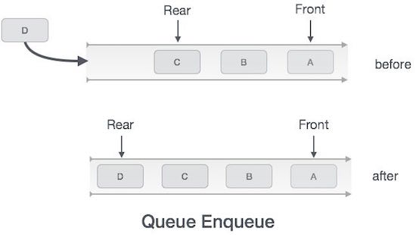

Sometimes, we also check to see if a queue is initialized or not, to handle any unforeseen situations.

### Algorithm for enqueue operation

procedure enqueue(data)

if queue is full

return overflow

endif

rear ← rear + 1

queue[rear] ← data

return true

end procedure

## Dequeue Operation

Accessing data from the queue is a process of two tasks − access the data where **front** is pointing and remove the data after access. The following steps are taken to perform **dequeue** operation −

* **Step 1** − Check if the queue is empty.
* **Step 2** − If the queue is empty, produce underflow error and exit.
* **Step 3** − If the queue is not empty, access the data where **front** is pointing.
* **Step 4** − Increment **front** pointer to point to the next available data element.
* **Step 5** − Return success.

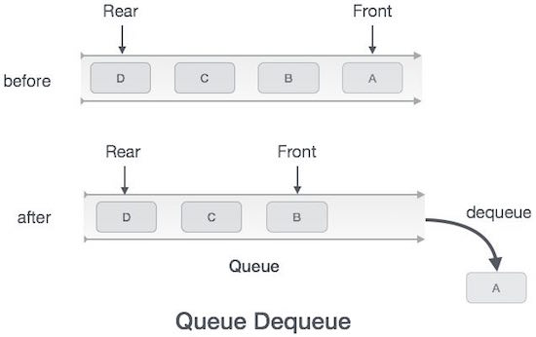

### Algorithm for dequeue operation

procedure dequeue

if queue is empty

return underflow

end if

data = queue[front]

front ← front + 1

return true

end procedure